A sense other than the usual 5…
Since the first time i saw the article on the web,i had wanted to do my review on the same. Pranav Mistry, the man who made it all, is one of the inventors of The Sixth Sense,turned his vision into a working prototype. He is a research assistant and a PhD candidate at MIT. Among some of his previous work, Pranav has invented MOUSELESS- an invisible computer mouse; intelligent sticky notes that can be searched, located and can send reminders and messages; a pen that can draw in 3D; and a public map that can act as Google of the physical world.

The SixthSense prototype comprises a pocket projector, a mirror and a camera contained in a pendant like, wearable device. Both the projector and the camera are connected to a mobile computing device in the user’s pocket. The projector projects visual information enabling surfaces, walls and physical objects around us to be used as interfaces; while the camera recognizes and tracks users' hand gestures and physical objects using computer-vision based techniques.The software program processes the video stream data captured by the camera and tracks the locations of the colored markers (visual tracking fiducials) at the tips of the user’s fingers. The movements and arrangements of these fiducials are interpreted into gestures that act as interaction instructions for the projected application interfaces. SixthSense supports multi-touch and multi-user interaction.
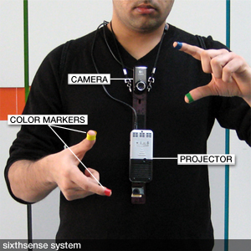
- The application in wide field activity varies,as such. The prototype has a lot of demonstration applications:
- The map application lets the user navigate a map displayed on a nearby surface using hand gestures to zoom and pan
- The drawing application lets the user draw on any surface by tracking the fingertip movements of the user’s index finger.
- SixthSense also implements Augmented Reality; projecting information onto objects the user interacts with.
- The system recognizes a user's free hand gestures as well as icons/symbols drawn in the air with the index finger, for example:
- A 'framing' gesture takes a picture of the scene. The user can stop by any surface or wall and flick through the photos he/she has taken.
- Drawing a magnifying glass symbol takes the user to the map application while an ‘@’ symbol lets the user check his mail.
- The gesture of drawing a circle on the user’s wrist projects an analog watch.
SixthSense was awarded the 2009 Invention Award by Popular Science.Now thats a lot about the prototype,dont u think? If u haven't come across the product yet,u must be a trifle bewildered on what it looks like and how it works. Well for u people here is a link,search it up on the web if u are really interested,and trust us when we say this,You WILL be AWESTRUCK!!!
http://www.youtube.com/watch?v=UM1AUUkXK_c

